MEMBERSHIP APPLICATION FORM

Please complete in BLOCK CAPITALS, including Christian Name and Surname.

Name (1) ____________________________________________________ D.O.B (if under 16) _______________

Name (2) ____________________________________________________ D.O.B (if under 16) _______________

Name (3) ____________________________________________________ D.O.B (if under 16) _______________

Address ___________________________________________________________________________________

___________________________________________________________________________________

Post Code ______________________________ Telephone number _____________________________________

Email Address _______________________________________________________________________________

How were you made aware of The Class 56 Group?

__________________________________________________________________________________________

Do you have any skills or talents that you think might be of benefit to the Group or do you work in the rail industry / preserved railway as a driver, fitter, etc.?

___________________________________________________________________________________________

CURRENT YEARLY MEMBERSHIP RATES

- Adult - £15.00  - Concessions (under 16, O.A.P’s & registered disabled) - £10.00  - Family * - £15.00 + 50p per additional family members | Multiple years are available if you prefer. Simply send your remittance for the number of years you wish to subscribe for.

* Family membership shall be for a group of individuals residing at the same address, of which at least one person must be sixteen or over. All persons to be covered are required to fill in their names and D.O.B. (if under 16) above.

I / we wish to join the membership of ‘The Class 56 Group’ at the Adult / Concessions / Family rate and agree to be bound by the rules of the Group, as stated in the constitution of the Group, a copy of which is available upon request from the Group Secretary (timdawe2@sky.com).

NUMBER OF YEARS SUBSCRIPTION REQUIRED FOR; _________ years AMOUNT PAID; £__________________
PAYMENT METHOD; Cheque [ ] / Postal Order [ ] / One-Off Bank Transfer [ ] / Annual Standing Order [ ] **
(** = tick as appropriate)
If paying by One-Off Bank Transfer or Annual Standing Order, please use the following details, quoting your full name as a reference;-
(The Bank of Scotland) Account Name; The Class 56 Group, Account Number; 25365569, Sort Code; 80-22-60
Cheques or Postal Orders should be made payable to ‘The Class 56 Group’.
CASH SENT THROUGH THE POST WILL NOT BE ACCEPTABLE.

SIGNED: ______________________________________________ DATE: ____________________________

Please send your completed form, together with a large stamped addressed envelope, to the Membership Secretary at the following address:-

The Class 56 Group, ‘Whernside’, 29 Bondend Road, Upton St. Leonards, Gloucester, GL4 8DX.

FOR OFFICE USE ONLY

Membership Number ________________________ Valid Until ____________________________

Member Since _____________________________ Notes _________________________________



Founded in 1992, the Class 56 Group was formed to cater for people who are interested in the heavy freight Class 56 diesel locomotives and wanted to see one or more of these fine machines preserved. Class 56 Group members and shareholders are currently the proud owners of two locomotives, British built 56301 (ex-56045), which is main line registered and used intermittently as a spot hire locomotive by Devon & Cornwall Railways (DCR), and Romanian built 56006, which is currently being restored into as built condition at the East Lancs Railway.

The Group offers news, details and information about the Class and Group activities via the Group’s website at www.class56group.co.uk and in a magazine, ‘GRIDIRON’, which is issued every four months. Members are invited to take a keen interest in the Group by submitting material for the magazine, website, attending meetings and getting involved with the Group sales stand at open days and galas. Also, learning what it takes to keep one of these fine machines in working order, as all levels of skills and abilities are always needed to keep the group functioning.

The Group now urgently needs more funds for the continued upkeep and maintenance of its locomotives. Therefore, please help us by becoming a member of the Group. If you wish to contribute further funds to the Group and its cause, we also run a share scheme to help with continuous funding, thus ensuring that the Class 56 locomotive lives on as part of British Railways history, and full details of this share issue can be sent to you upon request.

PLEASE JOIN US NOW ~ YOU KNOW IT MAKES SENSE!

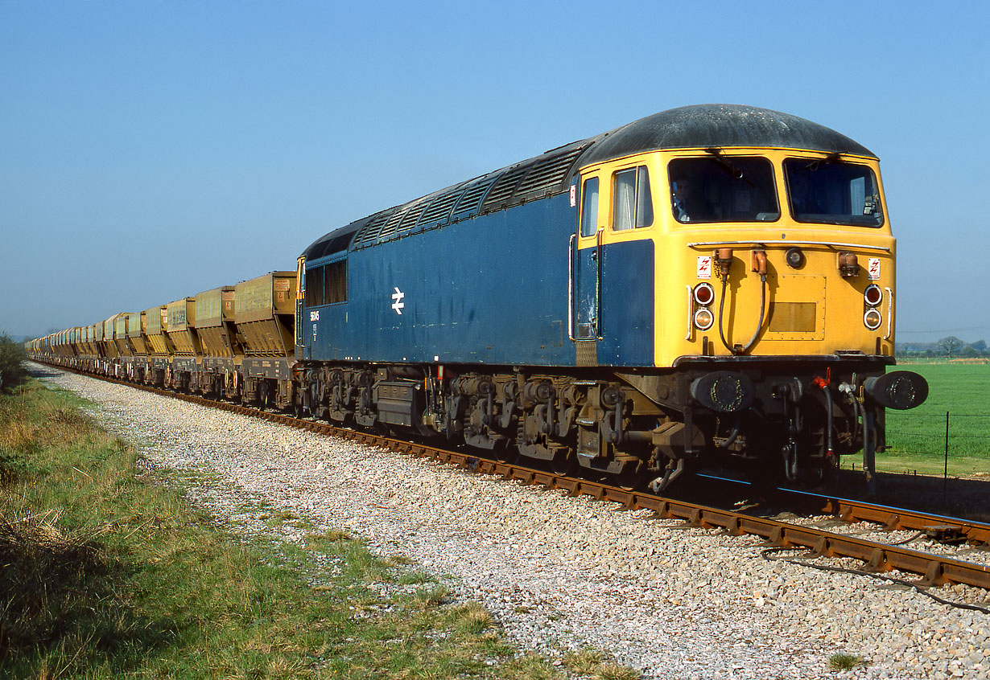 | 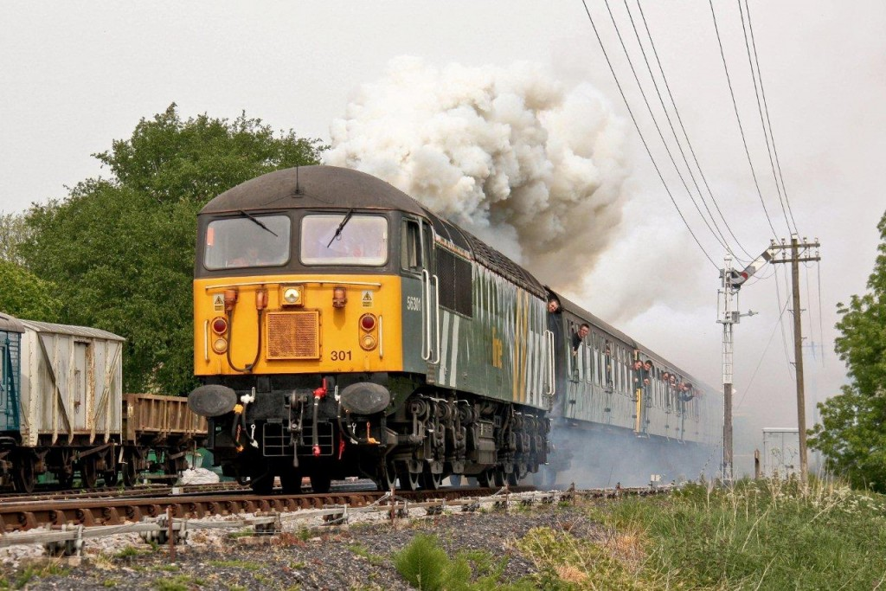
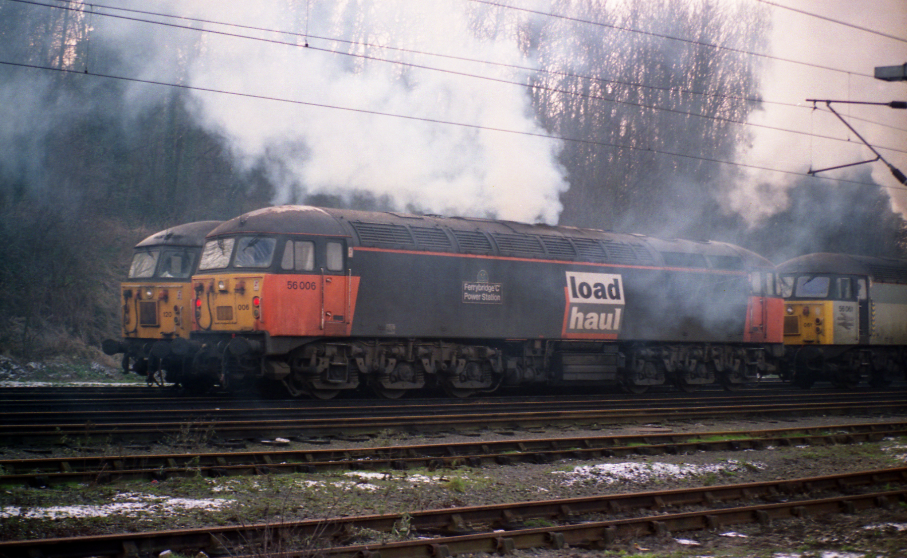 | 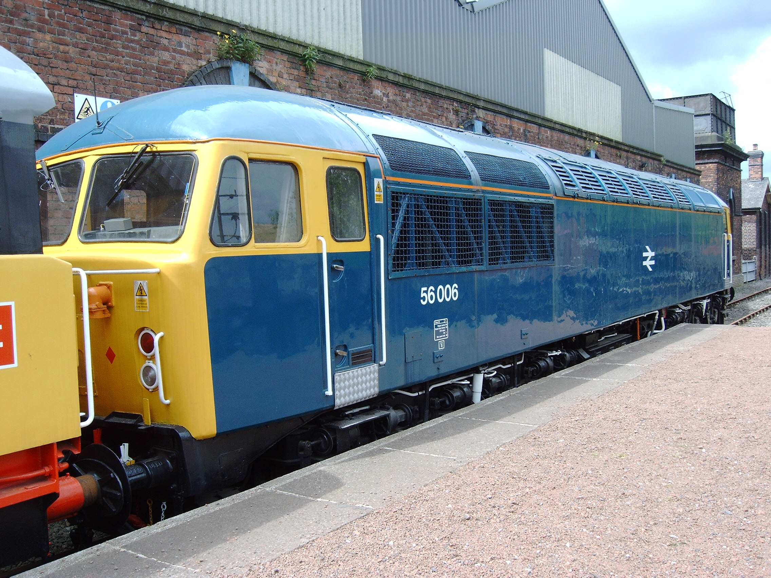

(photo’s courtesy of Martin Loader, Anon, Carl Rayner and the late Andrew ‘Brillo’ Wilson)

(please turn over for group membership details)

